MARITIMES EDUCATION WEEKLONG SCHOOL
SEMAINE DE FORMATION SYNDICALE DES MARITIMES

MONCTON, NB
Crowne Plaza Moncton

March 18th – 22nd, 2024
18 au 22 mars 2024

WORKSHOP REGISTRATION INFORMATION
INFORMATION SUR L’INSCRIPTION AUX ATELIERS

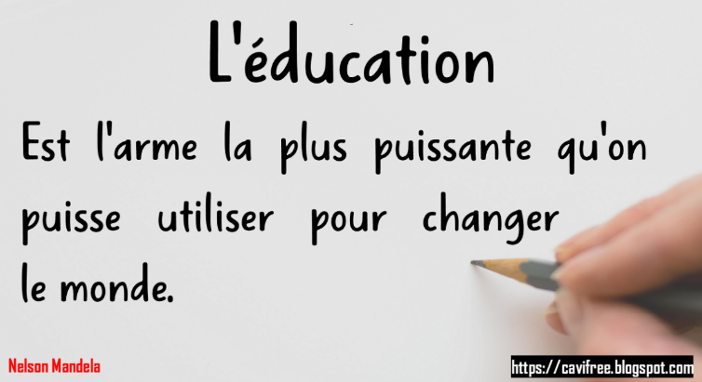

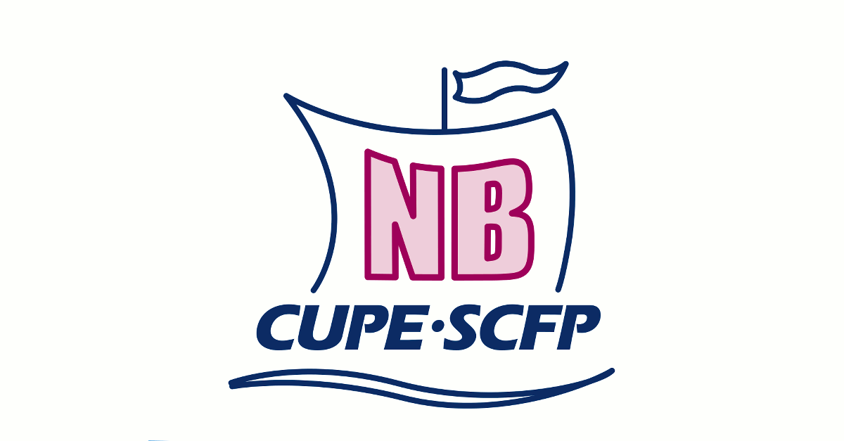

MARITIMES EDUCATION WEEKLONG SCHOOL

INFORMATION

SEMAINE DE FORMATION SYNDICALE DES MARITIMES
Who Can Attend | Qui peut Participer
The school is open to all NB & PEI CUPE executive members. | La formation est ouverte à tous les membres exécutifs du SCFP du NB et IPE.
Location | Endroit
Crowne Plaza Moncton  1005 Main Street  Moncton, NB  (506) 854-6340 | Crowne Plaza Moncton  1005, rue Main  Moncton, NB  (506) 854-6340
Accommodation | Hébergement
Participants and their locals are responsible for booking and paying for their own accommodation.  Rooms have been block-booked at the Crowne Plaza Moncton under “CUPE Maritimes Weeklong School”.  Please make your room reservations directly with the hotel prior to February 16th, 2024 in order to take advantage of this group rate. | Les participants et leurs sections locales sont responsables de réserver et de payer leur propre hébergement.  Des chambres ont été réservées en bloc à l'hôtel Crown Plaza Moncton sous ‘CUPE Maritimes Education School’.  Veuillez effectuer vos réservations de chambre directement auprès de l'hôtel avant le 16 février 2024 afin de bénéficier du tarif de groupe.
https://www.ihg.com/crowneplaza/hotels/us/en/moncton/yqmms/hoteldetail
Workshop Registration | Inscription aux Ateliers
Registrations will be conducted on a first-come, first-served basis through the provided links, and considered complete when payment is received.  We will not accept payment on site.  Payment must be sent before  the deadline date of February 16th. | L'inscription se fera selon le principe de premier arrivé, premier servi via le lien fournis, et considéré complète lorsque paiement reçu.  Nous n'accepterons pas de paiement sur place.  Le paiement doit être envoyé avant  la date limite du 16 février.
Registration Fees Includes: | Frais d’Inscriptions Comprennent :
- Workshop attendance | - Participation à l'atelier
- Morning & Afternoon tea, coffee & snacks  - Welcome reception & orientation | - Thé, café & collations le matin et l’après-midi  - Réception d’accueil & orientation
Scented products | Produits parfumés
In response to the health concerns of our members and staff, CUPE has implemented a Scent-Free Policy at all our workshops. Scented products can trigger reactions such a respiratory distress and headaches. Facilitators and participants are asked to refrain from using scented products while attending our workshops. Thank you for your cooperation. Those failing to follow this policy may be removed from their class until they can comply. | En réponse aux préoccupations de santé de nos membres et de notre personnel, le SCFP a mis en place une politique sans parfum lors de tous nos ateliers. Les produits parfumés peuvent déclencher des réactions telles que des difficultés respiratoires et des maux de tête. Nous demandons aux facilitateurs et aux participants de s'abstenir d'utiliser des produits parfumés lors de nos ateliers. Nous vous remercions de votre coopération. Les personnes ne respectant pas cette politique pourraient être demandées de ne pas assister aux ateliers jusqu'à ce qu'elles puissent s'y conformer.

MARITIMES EDUCATION WEEKLONG SCHOOL

INFORMATION

SEMAINE DE FORMATION SYNDICALE DES MARITIMES
Class Sizes | Taille de Classes
It will be limited to 25 participants. | Elle sera limitée à 25 participants.
Workshop Credits | Crédits d’Atelier
The participants will receive credits upon successful completion of the entire workshop. | Le participant recevra des crédits à son profile dès qu’il aura terminé avec succès l'ensemble des ateliers.
Code of Conduct | Code de Conduite
All participants are advised that a high standard of trade union behaviour is expected of them. All forms of harassment are unacceptable. Incidents will be dealt with in a fair and quick fashion and in accordance with the CUPE Code of Conduct. The CUPE Education Representative has the right to send participants home without refund in the event of inappropriate behaviour. | Tous les participants sont informés qu'un haut niveau de comportement syndical est attendu d'eux. Toutes les formes de harcèlement sont inacceptables. Les incidents seront traités de manière équitable et rapide, conformément au Code de conduite du SCFP. La conseillère à l'éducation du SCFP a le droit de renvoyer les participants chez eux sans remboursement en cas de comportement inapproprié.
Smoking/E-Cigarettes Policy | Politique de Tabagisme/Cigarettes-E.
The Crowne Plaza Moncton Downtown hotel is a non-smoking facility. You are requested to smoke/vape outside and three meters away from the doors and windows. | L’hôtel Crowne Plaza Moncton Downtown est un établissement non-fumeur. Nous vous prions de fumer/vapoter à l'extérieur et à trois mètres des portes et des fenêtres.
OMBUDSPERSONS | OMBUDSPERSONES
There will be CUPE Ombudspersons “on call” at the School. Ombudspersons attend CUPE events and try to resolve any complaints about behaviour that is inconsistent with CUPE’s Equality Statement or Code of Conduct. The phone number to call to reach an Ombudsperson will be posted at various locations including in each classroom. | Il y aura des ombudspersonnes du SCFP « en appel » au courant de la semaine. Les ombudspersonnes assistent aux événements du SCFP et tentent de résoudre les plaintes au sujet des comportements qui sont contre l'Énoncé sur l'Égalité ou le Code de Conduite du SCFP. Le numéro de téléphone pour joindre un(e) ombudspersonne sera affiché à divers endroits, y compris dans chaque salle de classe.
General Information | Informations Générales
In order to provide the best learning environment, the Education Representative reserves the right to:  - Cancel any workshop.  - Transfer or assign participants to any workshop.  - Limit the number of members any one local may send to a course. | Afin de fournir le meilleur environnement d'apprentissage, la conseillère de l'éducation a le droit de :  - annuler tout atelier.  - transférer ou assigner des participants à tout atelier.  - Limiter le nombre de membres qu'une section locale peut s’inscrire à un atelier.
Questions or Issues with Registration,  Please Contact: | Questions ou des problèmes avec l'Inscription, veuillez contacter :
Lynne LePage  Dalhousie CUPE Area Office  Phone: (506) 684-5518  Email: maritimeeducation@cupe.ca | Lynne LePage  Bureau du SCFP de Dalhousie  Téléphone: (506) 684-5518  Courriel: maritimeeducation@cupe.ca

MARITIMES EDUCATION WEEKLONG SCHOOL

REGISTRATION / INSCRIPTION

SEMAINE DE FORMATION SYNDICALE DES MARITIMES
REGISTRATION LINK: | LIEN D’INSCRIPTION
To register, please click on the link below :  https://cupe.ca/mrm-union-education/event/7118 | Pour vous inscrire, veuillez cliquer sur le lien ci-dessous:  https://scfp.ca/mrm-union-education/event/7118
NOTE: Your registration will only be considered complete upon receipt of payment. Payment must be submitted by the registration deadline of February 16th, 2024, or your spot will be forfeited. | REMARQUE : Votre inscription ne sera considérée comme complète qu'à la réception du paiement. Le paiement doit être soumis avant la date limite d'inscription du 16 février 2024, sinon votre place sera annulée.
REGISTRATION DEADLINE

Friday February 16th, 2024
Le vendredi, 16 février 2024

DATE D’ÉCHÉANCE D’INSCRIPTION

Make Cheque Payable to: CUPE/SCFP | Libellez le Chèque à l'Ordre de :  CUPE/SCFP
Fee: $500.00 (per participant) | Frais : 500$ (par participant)
Mail cheque to:  Dalhousie CUPE Area Office  396 Renfrew Street  Dalhousie, NB E8C 2K4  The member's name and workshop title must be stated on the check or on a separate piece of paper. | Envoyez le chèque à l'adresse suivante :  Bureau du SCFP de Dalhousie  396, rue Renfrew  Dalhousie, NB E8C 2K4  Le nom du membre et nom de l'atelier doivent être indiqués sur le chèque ou sur un papier séparé.
Refund Policy: | Politique de Remboursement :
- up to February 19th, 2024:  FULL REFUND  - after February 19th, 2024:  NO REFUND | - jusqu’au 19 février, 2024 :  REMBOURSEMENT COMPLET  - après le 19 février, 2024:  AUCUN REMBOURSEMENT

MARITIMES EDUCATION WEEKLONG SCHOOL

AGENDA / L’ORDRE DU JOUR

SEMAINE DE FORMATION SYNDICALE DES MARITIMES
TRACK #1
SLS – Steward Leaning Series
NOTE: Please bring your Steward Handbook & Collective Agreement to the workshop.
Introduction to Stewarding – 6hrs
What does a CUPE steward do? If you are a new steward and want to learn how to help CUPE members solve workplace problems, this introductory workshop is for you!
In this workshop, you will learn:
• investigating workplace problems;
• filing a grievance;
• meeting with management;
• dealing with workplace complaints.
Notetaking – 3hrs
Why do I have to take notes? What kind of notes should I take? Are my notes private? Learn answers to important questions like these, and practice notetaking.
Representing Members in Front of Management – 3hrs
This module equips stewards to be proactive when meeting with management. Learn tips for effective meetings and build confidence by practicing meeting situations.
Handling Discipline and Discharge – 3hrs
Learn about key legal concepts and terms, and the role of stewards during an employer’s investigation, when discipline is given, and during grievance meetings.
Grievance Handling – 3hrs
Share tips and successful practices with other stewards and learn strategies for handling difficult grievances.
Creating Accommodation-Friendly Workplaces – 3hrs
Learn the legal framework for the duty to accommodate, what a good accommodation process and plan look like, and what to do if the employer is not willing to provide reasonable accommodation.
Duty to Fair Representation – 3hrs
Learn about where stewards get their authority in the workplace, the duty of fair representation, and other labour laws that cover the workplace.
Ally Skills for Stewards – 3hrs
Effective stewards are champions for human rights and equality. Explore what it means to be an ally, and ways that stewards can step up as allies in the workplace and the union.
Growing our Mobilization Power – 3hrs
Stewards can play a key role when the union needs to mobilize our members – whether it’s to support the bargaining committee or stop the employer’s attempt to contract out our work. Learn basic mobilization theory and explore how stewards can tackle workplace problems in ways that engage more members and build the union’s power.

MARITIMES EDUCATION WEEKLONG SCHOOL

AGENDA / L’ORDRE DU JOUR

SEMAINE DE FORMATION SYNDICALE DES MARITIMES
TRACK #2
LET – Local Executive Training
NOTE: Please bring your Bylaws to the workshop.
Leadership Essentials – 9hrs
Who am I as a leader? Who are we as a local union? How do we fit into the broader movement? Learn how to use the power of your elected position to build power and strengthen solidarity in the union, in the labour movement and in our communities.
Parliamentary Procedures - 9hrs
This workshop is about following rules of order when chairing union meetings. Learn about the role of the chair and the different elements (motions, amendments, points of order, etc.). Get a chance to put the learning into practice.
Essentials for Inclusive Unions - 6hrs
As activists in our unions, we often ask why members are not more involved. This workshop asks a different question: Who is involved and who isn't and what might be some reasons why? How might our unconscious biases contribute to this? How can we represent members in a way that invites those on the margins to get involved and to see the union as place where they want to make a difference?
Duty of Fair Representation – 3hrs
Learn about your local's duty to represent the members in your union, the legal requirements of fair representation and how it applies to your collective agreement and other laws covering your workplace.
Leading as a Team – 3hrs
In this workshop, executive teams explore power and responsibility that comes with it, how we work in teams and how to balance our leadership styles to engage the membership and work effectively across diversity.

MARITIMES EDUCATION WEEKLONG SCHOOL

AGENDA / L’ORDRE DU JOUR

SEMAINE DE FORMATION SYNDICALE DES MARITIMES
TRACK #3
Health & Safety
NOTE: Please bring your Bylaws, Health and Safety Committee Resource Kit to the workshop.
Health and Safety - An Introduction – 9hrs
This course serves as an introduction into the world of health and safety and explores different basic concepts such as:
• Identification of hazards;
• Hierarchy of controls;
• The basic role of health and safety committees;
• Basics on the right to refuse.
Basics of Incident Investigations - 3hrs
Learn how to identify root causes of workplace incidents, injuries, and diseases, common routes of entry of toxic substances, and your role in the investigation process.
Identifying and Documenting Hazards - 3hrs
In this module, you will learn techniques for identifying hazards, such as body maps, surveys and inspections. You will also develop a methodology for dealing with the hazards you find.
Mobilizing around Health and Safety – 3hrs
In this workshop you will learn what mobilizing for health and safety looks like, how to engage members around health and safety in your workplace and how to create a mobilizing plan.
Violence Prevention – 3hrs
This module examines the risk factors that lead to violence in the workplace, and the employer’s obligations to prevent workers from being exposed to and injured by violence while at work. We examine relevant health and safety law and start to develop strategies to make our workplaces safer.
Workload and Overwork – 3hrs
As employers pull back resources, they expect workers to do more with less. This module will examine workload, the cause and effects of overwork, and strategies to overcome the ever-increasing workload that is damaging not just our health at work, but the relationship we have outside of work.
Recommendations and Notetaking – 3hrs
Learn how to takes notes at committee meetings and prepare recommendations.
Making Committees Work – 3hrs
This module explores the structure, role and function of health and safety committees, their strengths and limitations, and how they can best work within the legislative framework, and within our union.

MARITIMES EDUCATION WEEKLONG SCHOOL

AGENDA / L’ORDRE DU JOUR

SEMAINE DE FORMATION SYNDICALE DES MARITIMES
TRACK #4
Conflict
Conflict Resolution - 12hrs
Conflict is a natural part of our lives. Learning to handle it well improves relationships with other members, co-workers and the employer.
In this workshop, you will:
• deepen your understanding of conflict;
• strengthen your communication skills;
• practice responding to conflict..
SLS - Mediating Member-to-Member Conflict - 3hrs
Practice coaching members who are in conflict with other members, and work with a four-step approach to basic mediation.
SLS - Representing Gender and Sexually Diverse Members – 3hrs
Homophobia, biphobia, and transphobia play out in our workplaces, locals, and communities. Learn how to challenge these kinds of discrimination, and respectfully represent gender and sexually diverse members in your workplace.
SLS - Solidarity with Indigenous workers – 3hrs
Learn about Canada’s history of colonialism, engage in some myth-busting, and explore ways you can build solidarity with Indigenous workers and support reconciliation in the workplace.
SLS - Challenging racism in the workplace – 3hrs
This workshop covers what racism looks like in the workplace, and your role as a steward in challenging it.
Conflict at Work – 6hrs
Conflict is a natural part of our lives. Learning to handle it well improves relationships at work and in other parts of our lives.
In this workshop, you will:
-deepen your understanding of conflict
-learn how to identify the issues and find the right solutions
-strengthen your conflict communication skills

MARITIMES EDUCATION WEEKLONG SCHOOL

AGENDA / L’ORDRE DU JOUR

SEMAINE DE FORMATION SYNDICALE DES MARITIMES
TRACK #5
Français
N.B. : SVP apportez votre Convention Collective et manuel de la personne déléguée syndicale à l'atelier.
FESL - Diriger en Équipe – 3hrs
Dans cet atelier, l’exécutif explore le pouvoir et la responsabilité associés à son rôle, le fonctionnement du travail d’équipe et l'équilibre nécessaire dépendant du style de leadership pour impliquer les membres et pour travailler efficacement dans la diversité.
FESL - Devoir de Juste Représentation - 3hrs
Apprenez les fondements de votre devoir de représenter les membres de votre syndicat, les obligations légales de représentation juste et comment elles s'appliquent à votre convention collective et d’autres lois qui couvrent votre lieu de travail.
SDS - Représentation des Membres Devant la Direction - 3hrs
Ce module équipe les personnes déléguées syndicales afin qu’elles soient proactives lors de leur rencontre avec la direction. Apprenez des choses utiles pour des rencontres efficaces et découvrez comment renforcer votre confiance en vous en pratiquant des situations de rencontre à l’avance.
SDS - Créer des Milieux de Travail Adaptés – 3hrs
Apprenez le cadre légal qui entoure l’obligation d’accommodement, ce que sont et ce à quoi doivent ressembler un bon processus et un bon plan d’accommodation, et ce qui peut être fait si un employeur refuse de fournir des d’accommodements raisonnables.

N.B. : s.v.p. apporter votre Manuel de la personne déléguée syndicale à l'atelier.
SDS - Mesures Disciplinaires et Congédiement – 3hrs
Apprenez-en plus à propos des concepts et des termes juridiques utiles, ainsi que sur le rôle que doit jouer une personne déléguée syndicale pendant l’enquête d’un employeur, lorsqu’une mesure disciplinaire est prise, et pendant les réunions de grief.
SDS - Traitement des Griefs – 3hrs
Partagez des astuces et de bonnes pratiques avec d’autres délégués et apprenez des stratégies pour gérer les griefs difficiles.
FESL - Les Essentielles pour des Syndicats Inclusifs – 6hrs
En tant que militants dans nos syndicats, nous demandons souvent pourquoi les membres ne sont pas plus impliqués. Cet atelier pose la question différemment : Qui est impliqué, qui ne l'est pas et pourquoi ? Comment nos préjugés inconscients pourraient-ils y contribuer ? Comment pouvons-nous représenter les membres d'une manière qui invite les membres plus marginalisés à s'impliquer et à voir le syndicat comme un endroit où ils veulent faire la différence ?
SDS - Prendre des Notes – 3hrs
Pourquoi est-ce que je dois prendre des notes ? Quels types de notes devrais-je prendre ? Est-ce que mes notes sont privées ? Apprenez les réponses à des questions importantes comme celles-ci et pratiquez la prise de notes.
SDS - Le Pouvoir de la Mobilisation au Travail– 3hrs
Les personnes déléguées syndicales peuvent jouer un rôle clé quand le syndicat a besoin d’outiller nos membres, que ce soit pour soutenir le comité de négociation ou stopper les tentatives de l’employeur de sous-traiter notre travail. Apprenez-en plus sur la théorie de la mobilisation et explorez comment les personnes déléguées syndicales peuvent s’attaquer aux problèmes de façon à impliquer plus de membres et faire croître le pouvoir du syndicat.
lwl:cope*sepb491

